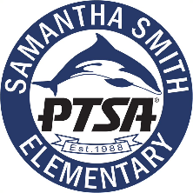
SMITH PTSA GENERAL MEMBERSHIP MEETING (Virtual)
Jan 13, 2022 @ 7-8:30 PM
Special Guests
Jamie Warner, Penne Lawler, Guest Speaker from LWSD
Attendees

Agenda
- Call to Order
- Approval of September 23, 2021, GMM Meeting Minutes
- Presentation by LWSD Guest Speaker, Barbara Posthumus on the 2022 Education Levy, 7-7:30PM
- This vote will fill gaps, maintain our investments as well as add classroom space for our growing district.
- An informational presentation from Dr. Jon Holmen https://youtu.be/L8joqYBr5wY
- Approval to support and endorse the upcoming Education levy on Feb 8.
- Treasurer’s Report-
- Thank you to our Fundraising Team and Contributors
- Approval of Budget for-
- A second Gaga Pit
- Magazine Grant to school for $2987
- Update from our Principal, Mrs. Warner
- Other Updates
- Adjourn

